Memorandum of Understanding

International Collaborations

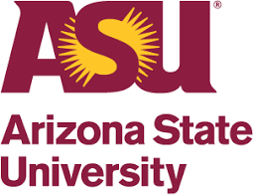 | Arizona State University, USA: The long-term collaboration between The NorthCap University and Arizona State University is focused on innovation and expanding access to quality higher education in India. NCU has been selected by ASU as its ﬁrst comprehensive university partner in India. Unlike conventional academic partnerships which are restricted to a school, department or program, this is a university-wide strategic collaboration between both institutions. NCU's alliance with Arizona State University represents a far-reaching collaboration focused on student success through innovation, access to global knowledge, and future pathways to higher studies.
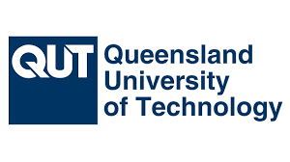 | Queensland University of Technology, Australia: The MoU with Queensland University of Technology is signed in July 2023. This MoU signifies a strong partnership aimed at fostering academic growth and innovation. The purpose of this agreement encompasses a range of exciting initiatives that are set to enhance the learning experience and global exposure of our students: Joint venture Projects, Academic and Scientific activities, Student and Faculty Exchange, Dual/Joint degrees, and Resource Exchange.
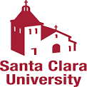 | Santa Clara University, California, USA: This MoU was signed in June 2023 to offer graduate program at SCU to undergraduate students of NCU with an application fee waiver, two annual scholarships worth US$9000 for engineering applicants and two annual scholarships of US$12000 for business studies applicants.
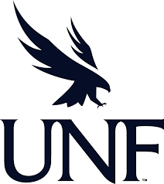 | The University of North Florida, USA: The NCU has a collaboration with UNF, Florida, USA and the MoU is signed in March 2023. The agreement is signed for the Exchange of Faculty and Administrative/Professional staff, the exchange of students, Immersion Programmes, Research Collaborations and Joint Degrees.
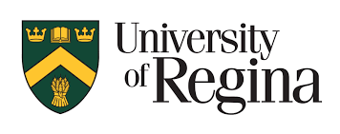 | University of Regina, Canada: The MoU with University of Regina, Canada was signed in June 2016 and is renewed in 2023. Both sides make a sincere effort to promote collaborative research and educational endeavors, including the sharing of academic resources and publications, the exchange of professors for research, presentations, and discussions, and the exchange of students for study and research. For NCU BTech ECE and CSE students, the articulation process for the 3+1+MEng/MASc programme with U of R is now underway. After finishing their three years of BTech at NCU, the chosen candidates will be able to transfer to the University of Regina in Canada.
 | Shibaura Institute of Technology, Japan: A Partnership Agreement with Shibaura Institute of Technology, Japan was signed in August 2018 and is renewed in June 2023, to undertake collaborative research and joint academic meetings, exchange of professors, researchers and students. Admission and Tuition fees are waived for NCU students on semester exchange.
 | Salem State University, USA: The NCU has a collaboration with Salem State University, USA. The agreement is signed in March 2023 for educational exchange programs which includes Short and long-term exchange of faculty members and non-academic staff and student exchange. It also focuses on Collaborative research, summer internship/immersion, and Dual/Joint degrees.
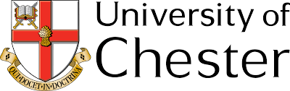 | University of Chester, UK: A Partnership Agreement with the University of Chester, UK, was signed in 2012.The Chester Business School has over 1500 students with campuses at Chester and Warrington and has a good reputation at undergraduate and postgraduate-level courses.
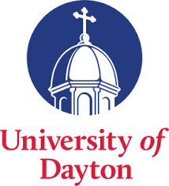 | University of Dayton, Ohio, USA: The University has signed a partnership agreement to undertake joint collaborative research and for student and faculty exchange programmes. The agreement was signed in May 2017.
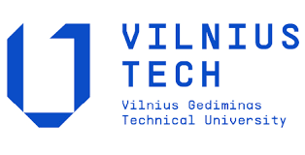 | Vilnius Tech University, Lithuania: The NCU has a collaboration with Vilnius Tech University, Lithuania and the MoU is signed in June 2023. The agreement is signed for the Exchange of Faculty and Administrative/Professional staff, the exchange of students, Immersion Programmes, Research Collaborations and Participation in conferences (including online), symposiums, short courses and scientific workshops.
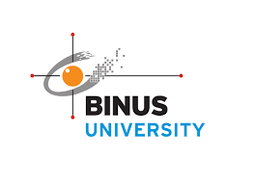 | Binus University, Indonesia: The NCU has established a collaboration with Binus University, located in Indonesia. The Memorandum of Understanding (MoU) between the two institutions was signed in September 2023. The agreement aims to facilitate the exchange of information and experience related to educational exchange programmes, student exchange, immersion programmes, research collaborations, and joint degrees, including joint online programmes.
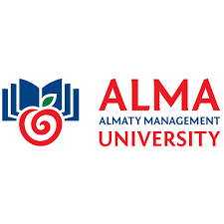 | Almaty Management University, Kazakhstan: The NCU has signed cooperation agreement and students exchange agreement with AlmaU in October 2023. The agreement is signed for exchange of faculty, students and researchers, Masters and Doctoral degree supervision, access to Online courses, Joint organization of forums and conferences, Entrepreneurship areas: Social Incubator and others.
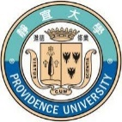 | Providence University, Taiwan: A Partnership Agreement with Providence University, Taiwan was signed in October 2018, to undertake special short-term academic programs, joint collaborative research and for student and faculty exchange programmes.
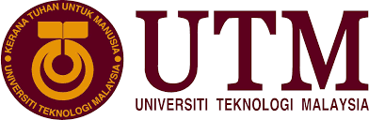 | Universiti Teknologi, Malaysia: A Partnership Agreement with Universiti Teknologi, Malaysia was signed in August 2020, for summer school, short courses and training, joint research and supervision, researcher/faculty/student attachment and exchange programmes.
 | Universidad Autonoma de Guadalajara (UAG), Mexico: A partnership agreement with Universidad Autonoma de Guadalajara (UAG), Mexico was signed in August 2021, for co-teaching, academic and cultural exchange of students and faculty, summer school, short courses and training, and joint research.
 | UDF Centro Universitario, Brazil: An MoU is signed with UDF, Brazil in December 2022. The agreement is between Law schools of both the universities for academic exchange programmes for students and faculty, joint organization of seminars, conferences and workshops and exchange and access of academic publication materials.
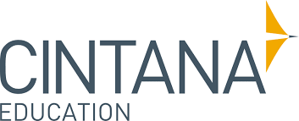 | Cintana Alliance: The long-term collaboration between The NorthCap University and Cintana Alliance is focused on collaboration with other 16 universities across the continents. Students benefit in terms of semester abroad at zero fee, immersion programmes at universities across 16+ universities with scholarships, joint research projects and funding and opportunity to participate in international competitions.
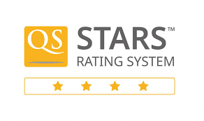 | QS Star Rating: The NorthCap University has achieved QS 4 stars overall and a perfect 5-star rating in important categories of Teaching, Employability, Online learning, Academic development, and Inclusiveness from QS Quacquarelli Symonds - the global rating agency. This puts NCU among the top 10 universities in India for academic quality.

